Moderated Moderation Example

Variables:

* DV: Student success
* IV: (X) ACT criterion
* IV: GPA (M)
* IV: Hours (W)

**Assumption Checks:** Since assumption checks are the same for all types of regression analyses, please see above for how to run this assumption check.

1. Missing data – does not appear that we have any.

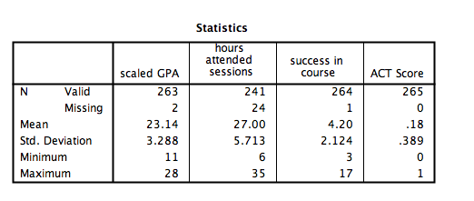

1. Outliers – note how BOTH IVs are in the independents box.

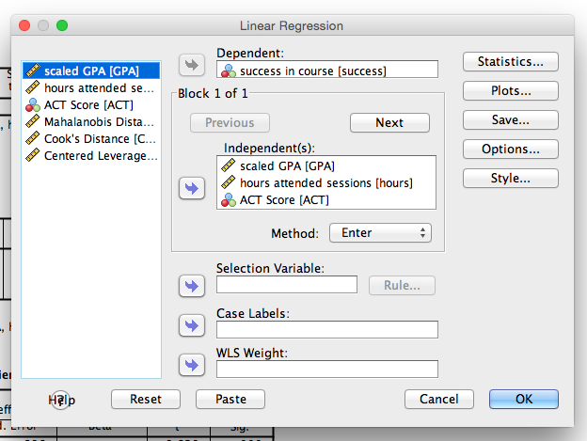

(so you won’t have an interaction yet here because we are just screening the variables before running the moderation analysis).

1. Mahalanobis cut off X2(3) *p* < .001 = 16.27.
2. Leverage = = .15
3. Cooks = 4/37 = .11
   * 1. Since this person was only outside Cook’s range, I’m going to leave them in.
4. Multicollinearity
   1. Analyze > correlate > bivariate

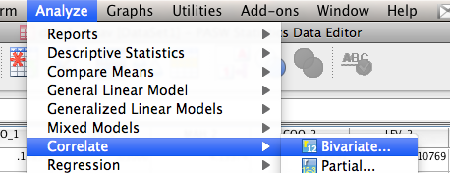

* 1. Move all the independent variables over (not the DV!)

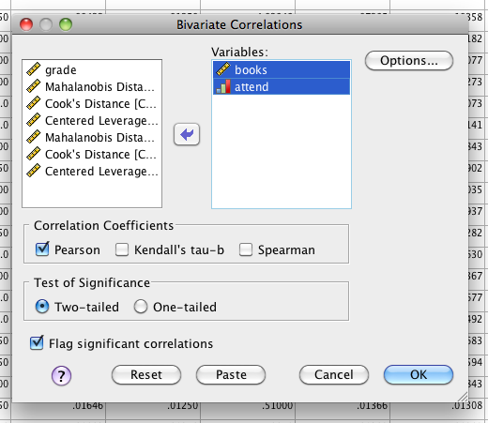

* 1. Make sure nothing is over .9

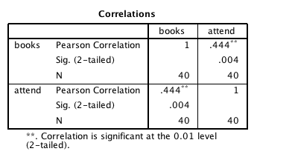

1. Normality

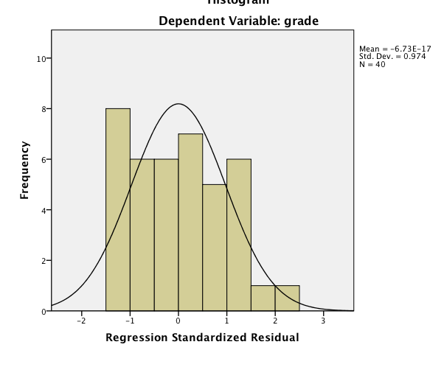

1. Linearity

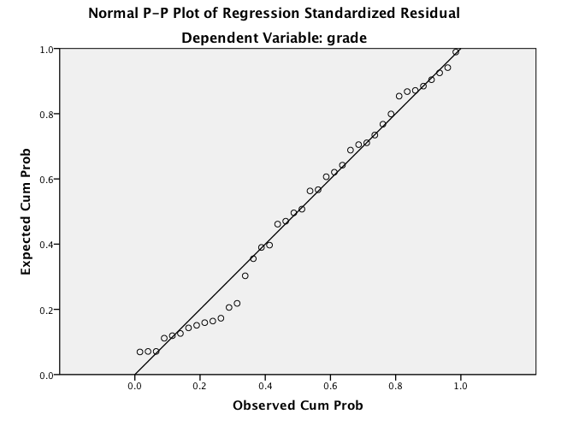

1. Homogeneity/Homoscedasticity

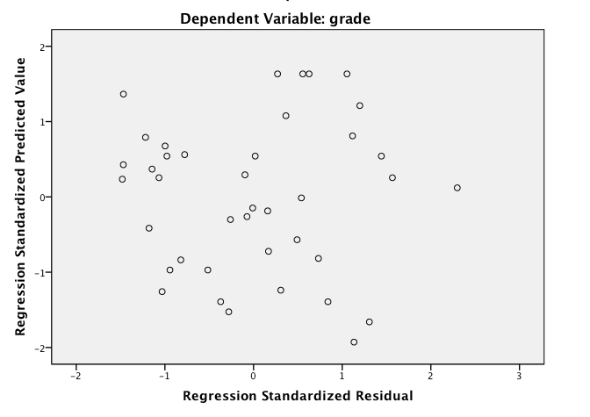

**How to run the analysis in PROCESS:**

Analyze > regression > PROCESS

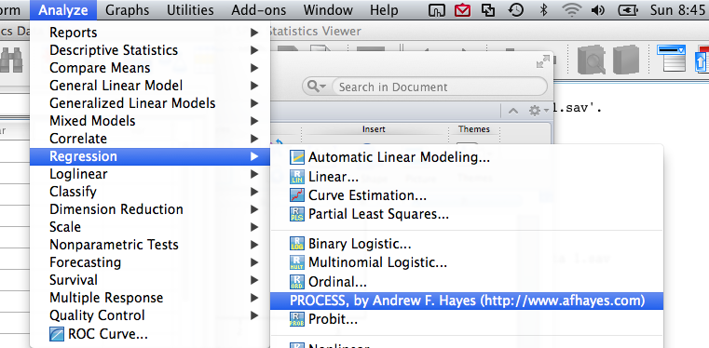

Here is the PROCESS window.

Click options, for moderation you will want to click the first four options.

* Mean center for products = centering of the variables.
* Heteroscedasticity consistent SEs = bootstraps the standard error, means they are better estimated because they have been estimated 1000 times (see above).
* OLS/ML confidence intervals = ordinary least squares/maximum likelihood confidence intervals, type of estimation for confidence intervals since it runs a lot of bootstrapped samples.
* Generate data for plotting = creates the numbers needed to create a graph for you.

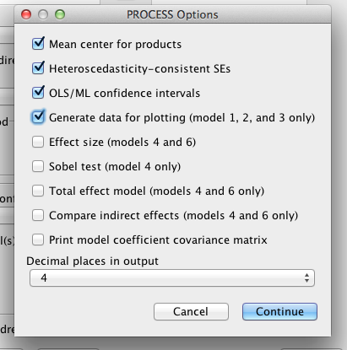

Click conditioning.

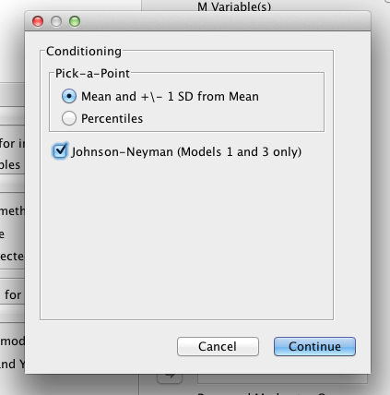

You want to leave mean and +/- 1SD mean – that’s the normal way to create groups for an interaction.

Click on the Johnson-Neyman zones of significance.

Graphs:

Graphs > Chart Builder

Click line graphs.

Double click the second line graph option (multiple line).

Note: the IVs will need to be labeled as nominal in SPSS.

Normally you will stick the moderator in the “set color” option.

Stick the other IV in the x-axis.

Stick the DV in the y-axis.

Note: you will not be able to do error bars because we have a summary of the data, rather than the actual data.